7.4 Main Question (สำหรับแสดงข้อสอบ)

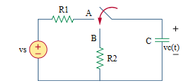

Given *vs* = 40 V, *R*1 = 5k Ω, *R*2 = 2k Ω, *C* = 10 µF.

Find

Variables (สำหรับเขียนโค้ดเพื่อหาคำตอบ)

Random variables

vs = {10:40};

r1 = {1000: 10000: 1000};

r2 = {1000: 10000: 1000};

c = {1e-6:1e-5:1e-6};

time = {1:5};

Global variables

# vs = 40; r1 = 5000; r2 = 2000; c = 10/1000000; time = 1;

vc0 = vs;

req = r2;

tau = req*c;

vct = vc0*exp(-time);

Part (กรอกคำตอบ)

1. *vc*(0-) = vc0 = 40 V

2. *vc*(0+) = vc0 = 40 V

3. *τ* = tau = 0.02 s

At *t* > 0

4. *vc*(*t*) = vc0*exp(-t/tau) = 40*exp(-t/0.02) V

5. *vc*(time*τ*) = vct =14.715 V

7.5

Main Question (สำหรับแสดงข้อสอบ)

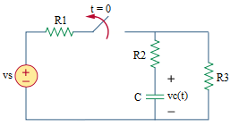

Given *vs* = 24 V, *R*1 = 2 Ω, *R*2 = 5 Ω, *R*3 = 4 Ω, *C* = 1/3 F.

Find

Variables (สำหรับเขียนโค้ดเพื่อหาคำตอบ)

Random variables

r1 = {1:10:1};

r2 = {1:10:1};

c = {1/3:10/3:1/3};

time = {1:5};

Global variables

# vs = 24; r1 = 2; r2 = 5; r3 = 4; c = 1/3; time = 1;

vc0 = (r3/(r1+r3))*vs;

tau = (r2+r3)*c;

vct = vc0*exp(-time);

Part (กรอกคำตอบ)

1. *vc*(0-) = vc0 = 12 V

2. *vc*(0+) = vc0 = 12 V

3. *τ* = tau = 3 s

At *t* > 0

4. *vc*(*t*) = vc0*exp(-t/tau) = 16*exp(-t/3) V

5. *vc*(time*τ*) = vct = 5.88 V

7.6

Main Question (สำหรับแสดงข้อสอบ)

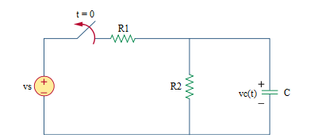

Given *vs* = 40 V, *R*1 = 10 kΩ, *R*2 = 2 kΩ, *C* = 40 µF.

Find

Variables

Random variables

r1 = {1000: 10000: 1000};

r2 = {1000: 10000: 1000};

c = {1e-5: 1e-4: 1e-5};

time = {1:5};

Global variables

# vs = 40; r1 = 10000; r2 = 2000; c = 40e-6; time = 1;

vc0 = (r2/(r1+r2))*vs ;

tau = r2*c;

vct = vc0*exp(-time);

Part (กรอกคำตอบ)

1. *vc*(0-) = vc0 = 6.667 V

2. *vc*(0+) = vc0 = 6.667 V

3. *τ* = tau = 2/25 s

At *t* > 0

4. *vc*(*t*) = vc0*exp(-t/tau) = 6.667*exp(-12.5t) V

5. *vc*(time*τ*) = vct = 2.45 V

7.9

Main Question (สำหรับแสดงข้อสอบ)

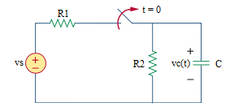

Given *vs* = 6 V, *R*1 = 2 kΩ, *R*2 = 4 kΩ, *C* = 3 mF.

Find

Variables

Random variables

r1 = {1000: 5000: 1000};

r2 = {1000: 5000: 1000};

c = {1e-3: 5e-3: 1e-3};

time = {1:5};

Global variables

# vs = 6; r1 = 2000; r2 = 4000; c = 3e-3; time = 1;

vc0 = (r2/(r1+r2))*vs;

tau = r2*c;

vct = vc0*exp(-time);

Part (กรอกคำตอบ)

1. *vc*(0-) = vc0 = 4 V

2. *vc*(0+) = vc0 = 4 V

3. *τ* = tau = 12 s

At *t* > 0

4. *vc*(*t*) = vc0*exp(-t/tau) = 4*exp(-t/12) V

5. *vc*(time*τ*) = vct = 1.47 V

7.10

Main Question (สำหรับแสดงข้อสอบ)

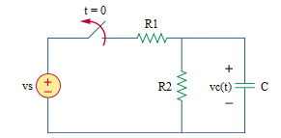

Given *vs* = 36 V, *R*1 = 9 kΩ, *R*2 = 3 kΩ, *C* = 20 µF.

Find

Variables

Random variables

r1 = {1000: 10000: 1000};

r2 = {1000: 10000: 1000};

c = {1e-5: 1e-4: 1e-5};

time = {1:5};

Global variables

# vs = 36; r1 = 9000; r2 = 3000; c = 20e-6; time = 1;

vc0 = (r2/(r1+r2))*v;

tau = r2*c;

vct = vc0*exp(-time);

Part (กรอกคำตอบ)

1. *vc*(0-) = vc0 = 9 V

2. *vc*(0+) = vc0 = 9 V

3. *τ* = tau = 0.06 s

At *t* > 0

4. *vc*(*t*) = vc0*exp(-t/tau) = 9*exp(-t/0.06) V

5. *vc*(time*τ*) = vct = 3.31 V